**Input image I**

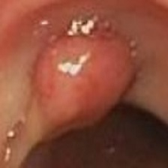

**特征提取**

**Feature X**

**Proposal scores**

**Xc=Dr**



**目标检测**

**fc6**

**fc7**

**Pooled feature**

**...**

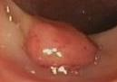

**Selective Search**

**目标框生成**